20th December 2017

**YOKOHAMA to Exhibit at Tokyo Auto Salon 2018**

YOKOHAMA will again participate in Japan’s annual celebration of the custom car, the “Tokyo Auto Salon 2018” to be held 12th – 14th January at Makuhari Messe. In addition to appealing to the “High-performance YOKOHAMA” brand image focused on the Company’s global flagship “ADVAN” brand, this time’s exhibit will also appeal to the “Rain-safe YOKOHAMA” image by displaying several tyres with superior wet-grip performance. The YOKOHAMA exhibit will again have a tyre booth and a wheel booth.   
  
The tyre booth will enhance the “ADVAN” brand’s image as a high-performance tyre by showcasing the racing car that captured the 2017 championship in Asia’s ultimate formula racing car series, the Japanese SUPER FORMULA Championship Series, which was again run solely on “ADVAN” racing tyres. Featured tyre products will include the “ADVAN Sport V105”, which has been adopted as original equipment on several of the world’s leading premium car models; the “ADVAN dB V552”, which was launched in late 2017 as the most silent tyre ever developed by the Company; and the “ADVAN HF Type D”, launched in 2017 as YOKOHAMA’s first tyre targeted at the historic car market. Each of these featured tyres will be displayed on a European- or Japanese-made custom car or tuning car, thus highlighting the “ADVAN” series’ suitability for use on a diverse variety of car types.   
  
In addition to “ADVAN” tyres, the “Rain-safe YOKOHAMA” theme will appeal to the Company’s considerable technological strength through the display of several tyres in the “BluEarth” series of fuel-efficient tyres that have received the Japan tyre labeling system’s highest “a” grade for wet grip performance—including the “BluEarth-A,” which combines high performance with fuel efficiency. Visitors to the YOKOHAMA exhibit will be able to purchase a number of popular ADVAN goods. Scheduled on-stage events at this time’s Tokyo Auto Salon include talk shows featuring teams and drivers from the Japanese SUPER FORMULA Championship series and SUPER GT series who will share their experience running races on YOKOHAMA tyres. Visitors will also be able to see videos introducing new YOKOHAMA tyres on a large LED display.   
  
The exhibit’s wheel booth will mainly feature “ADVAN Racing” aluminum wheels, including the unveiling of several new wheel products. The on-display cars will showcase the ADVAN Racing RZ-F2, the first full-faced model in the “ADVAN Racing” brand of forged aluminum wheels, and the “ADVAN Racing TC4,” which recently underwent a model change.

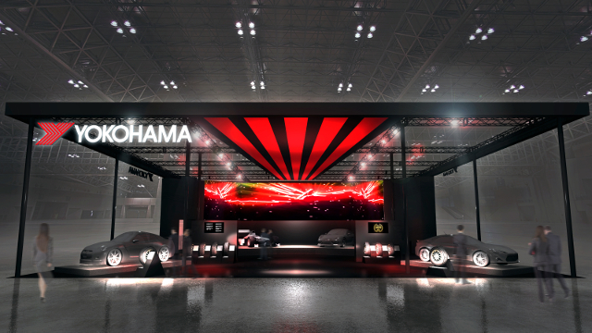

*The YOKOHAMA tyre booth at Tokyo Auto Salon 2018*